Name of the Applicant: Shanmukha Priya .K Total no. of sheets: 2

Saveetha Institute of Medical And Technical Sciences, Arbaz Sherief M,

Dr. K. Malathi, Dr. B. Ramesh, Dr. Ramya Mohan.

Sheet no: 1 of 2

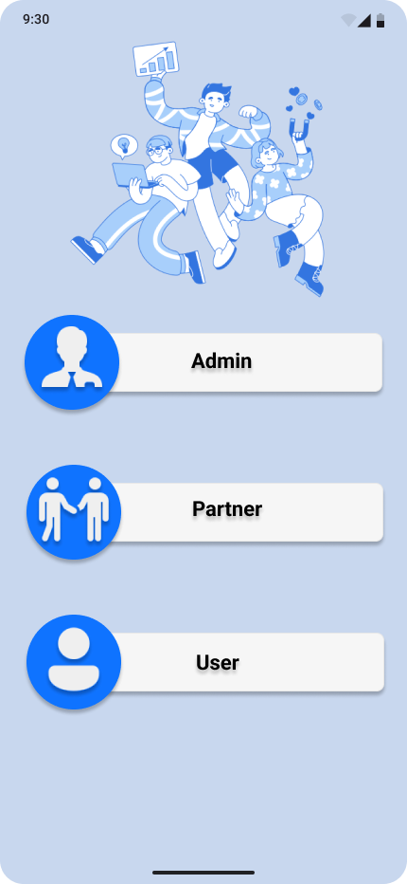

[EasyPark Android Application]

The novelty resides in the shape and configuration “**EasyPark Android Application**” of the article as illustrated.

No claim is made by virtue of this registration in respect regarding any aspect related to Electrical Equipment Maintenance features or functionalities of the application or Development of the Emaintenance Android platform.

No claim is made by virtue of the registration to any rights to the exclusive use of the words, letters, numbers, colours, colour combination or trademarks as appearing in the representations.

Name of the Applicant: Shanmukha Priya .K Total no. of sheets: 2

Saveetha Institute of Medical And Technical Sciences, Arbaz Sherief M,

Dr. K. Malathi, Dr. B. Ramesh, Dr. Ramya Mohan.

Sheet no: 2 of 2



[EasyPark iOS Application]

The novelty resides in the shape and configuration “**EasyPark iOS Application**” of the article as illustrated.

No claim is made by virtue of this registration in respect regarding any aspect related to Emaintenence features or functionalities of the application or Development of the Emaintenance iOS platform.

No claim is made by virtue of the registration to any rights to the exclusive use of the words, letters, numbers, colours, colour combination or trademarks as appearing in the representations.